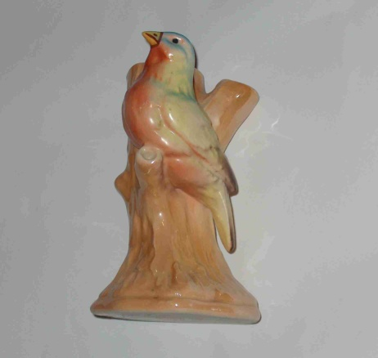 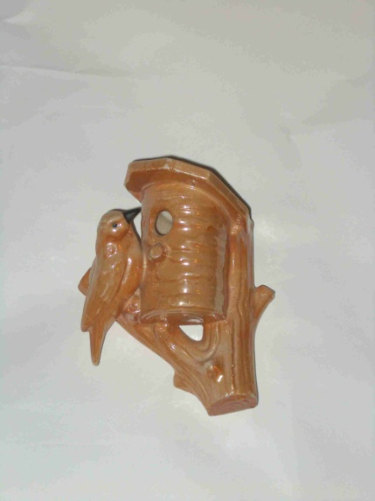 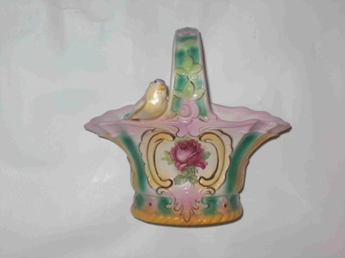

One of the two most common wall pockets, but in rare gold luster.

Unusual color of a bird on a basket

A common style bird, but is larger and has a rare gold luster tree trunk.

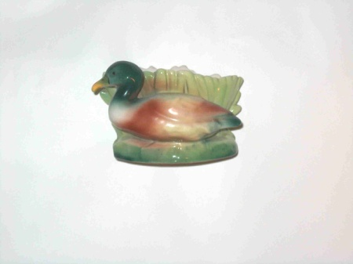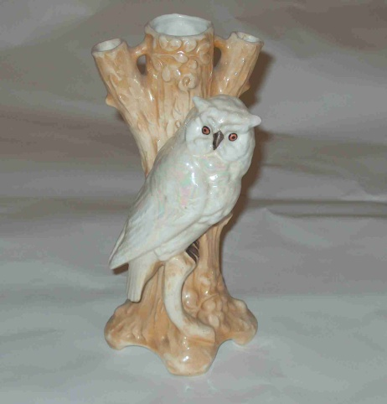 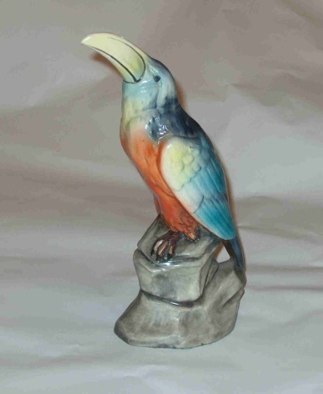

Very rare toucan bird, 10 inches

One of several sizes of owl vases, this one measuring 9 inches tall of gold and white luster

Rare duck planter, measures about 4 inches

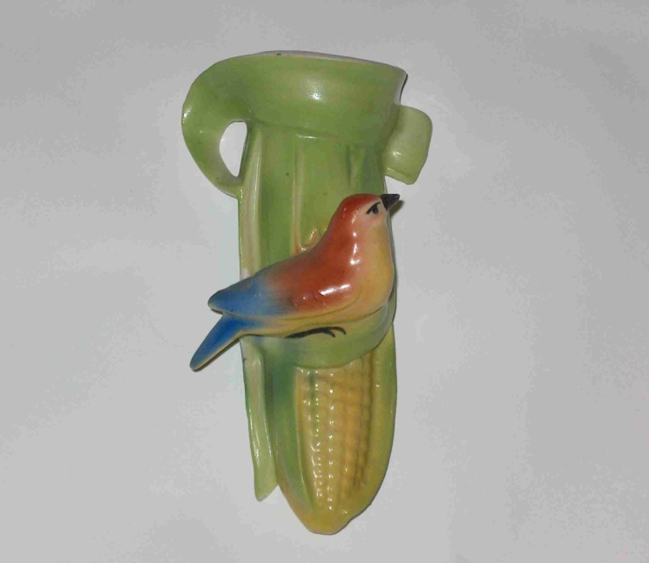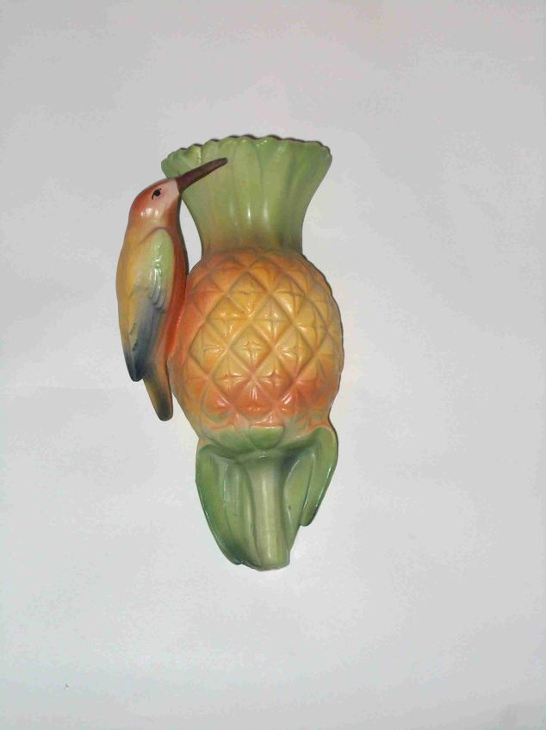

The Holy Grail of bird collecting is the bird on the pineapple. Favorite of bird collectors.

Uncommon bird on an ear of corn

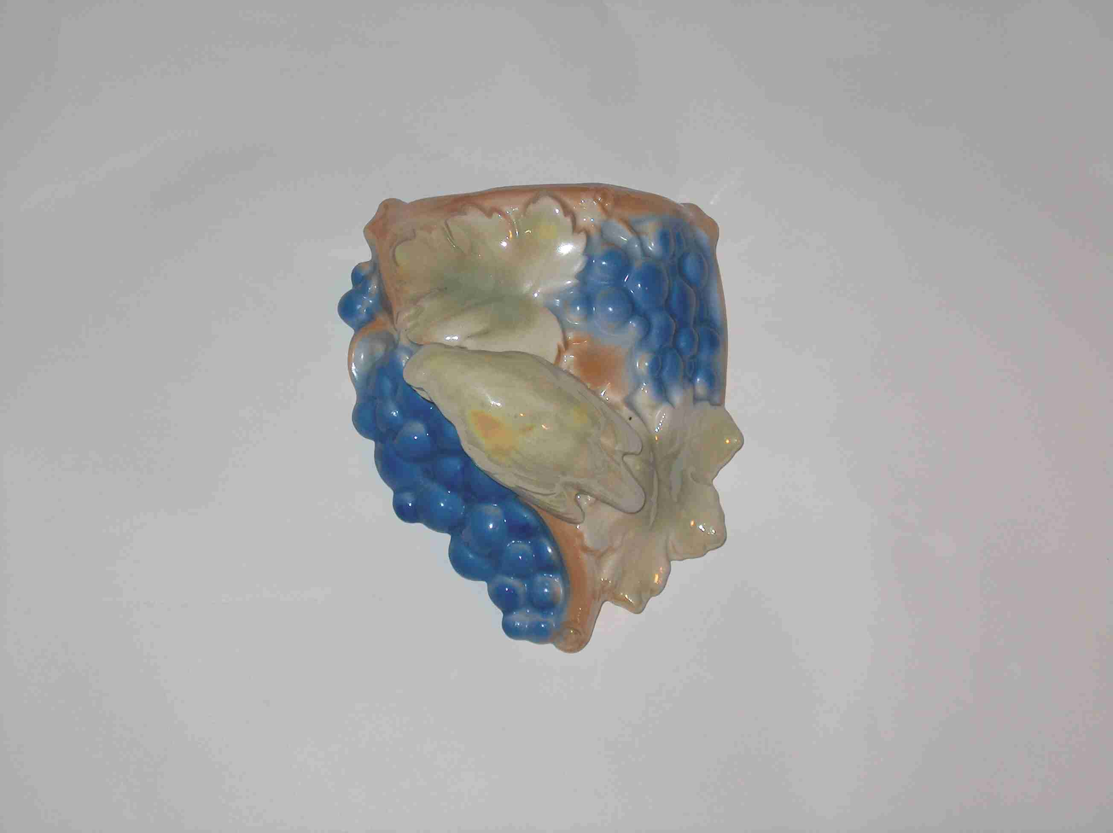

Rare luster bird on grapes WP. The largest of three sizes brought $1580 on eBay!